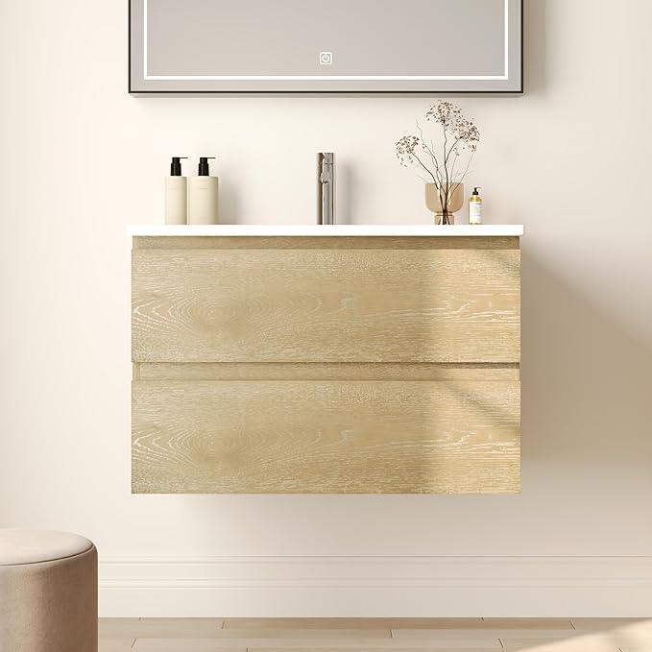

$259

Deer Valley DV-1BV0152NW 30'' Wall Mounted Bathroom Vanity with Ceramic Sink Top, Pre-Assembled Modern Floating Wood Bathroom Cabinet Sink Combo with 2 Drawers